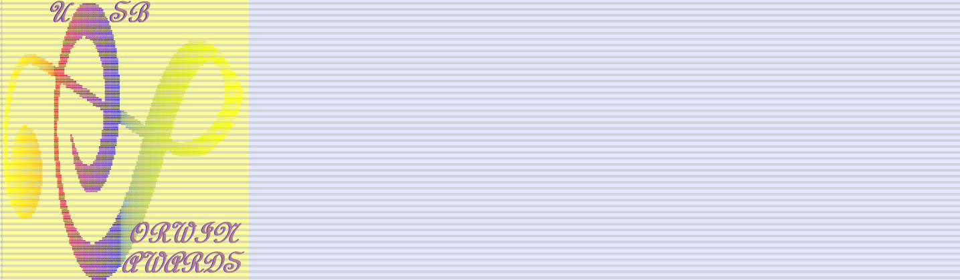 **THE UNIVERSITY OF CALIFORNIA SANTA BARBARA**

**DEPARTMENT OF MUSIC**

**announces the**

**2025**

**DOROTHY and SHERRILL C. CORWIN AWARDS**

**for Excellence in**

**MUSIC COMPOSITION**

**1) Work for Large Ensemble (more than 5 performers)**

(Examples: orchestra/wind ensemble, choir, percussion ensemble, with/without soloists, electronics and/or fixed media)

**2) Work for Chamber Ensemble (1 – 5 performers)**

(Examples: solos, duos, trios, quartets, vocal group, percussion ensemble, with/without electronics and/or fixed media)

**3) Electronic Music**

(Examples: Fixed media audio or audio-visual)

 Awards are open to all UCSB undergraduate and graduate student music majors in the   
 Music Department, the College of Creative Studies, and the Media Arts and Technology Program registered during the academic year 2024-2025. In all categories there will be one prize for undergraduate level ($450) and one prize for graduate level ($700).

 Every applicant may submit a maximum of two pieces in all categories. Submission forms are available [here](https://music.ucsb.edu/sites/default/files/corwin%20forms/Corwin%20Awards%202023%20Submission%20Form.docx).

 Each applicant must submit a full score (pdf) and recording, if available (mp3, aiff or wav). Multichannel works must be supplied in stereo and multichannel.

 Please upload your scores and recordings to a file transfer site (hightail, dropbox, or similar). Make sure link remains active till June 2025 and no password is required. Link to download all materials must be included in the submission form. Neither the Department of Music nor the grantor of the awards assumes any responsibility for malfunctioning transfers or links.

 Decisions of the judges are final. If the judges do not find an entry of merit in any of the three categories, an award will not be made in that category.

**Deadline for submissions: April 30th, 2025**

-------------------------------------------------------------------------------------------------------------------------------

Address entries and inquiries to: Dorothy and Sherrill C. Corwin Awards

1315 Music Office, Department of Music, UCSB

jppo@ucsb.edu